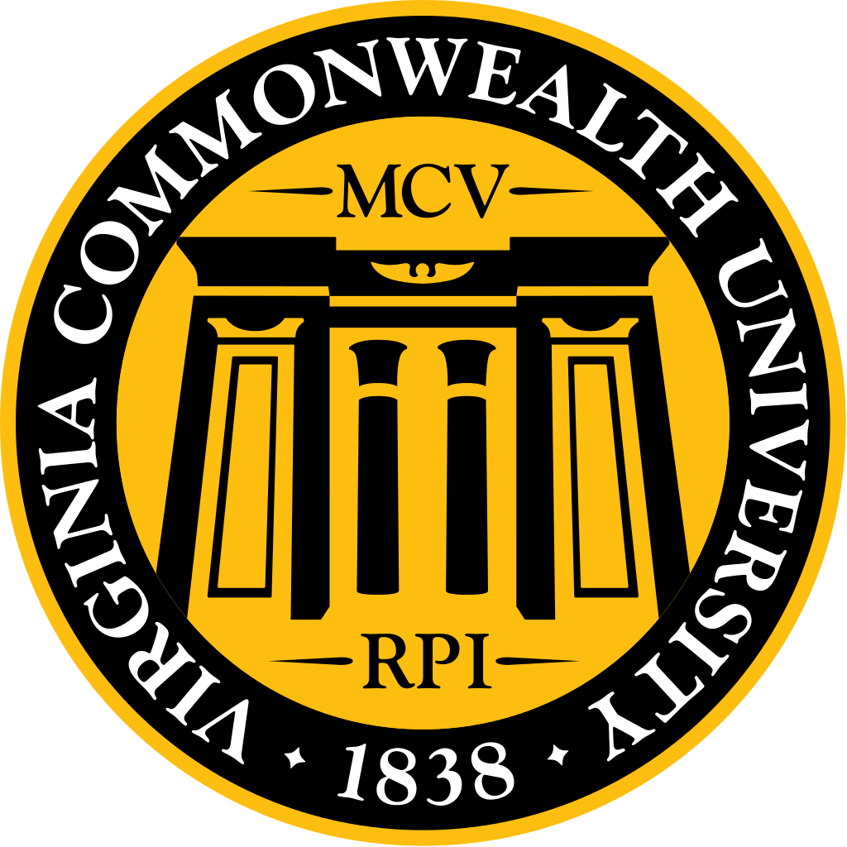
January Dean’s Luncheon
Reminder of our main forms of communication:
- MSG website – http://www.vcumsg.org/
- MSG weekly scoop (attached)
Please join us for our upcoming events:
- Match Day, Friday, March 17th

Highlights:
- Dean Strauss’ last luncheon as Dean. Commitments to programs and students will remain strong the transition to the new dean.
- Hospital construction projects will be starting in the next couple of months.
- M4s finishing up interviews. 2 people matched into Ophthalmology.
- M3s are creating their 4th year schedule and getting advisors.
- Please turn in jump drives by April 17th (INOVA students can return theirs at INOVA). Jump drives are needed to take tests on macs.
- Class of 2020 needs to turn in checks so that uworld can be ordered.
- Step 2 scores are taking longer to come out. Encourage students to take Step 2 CS before mid September. Working on practice OSCE to help prep for step 2 CS.
- M1 orientation will start on August 7th, 2017.
- Access to Sanger hall after hours is located on Marshall street entrance and will eventually become the only access.
- Security changes will be happening over the next few months. Decision are being made based on safety, cost is secondary.
- New tour guides have been great. Open house is on March 25th.
- Work to decrease mistreatment is ongoing. Setting up a button on the intranet for mistreatment for house officers or students from any health school. Planning on doing more educational campaigns.
- Class officers are your elected officials and should be what the student body wants and the administration is happy to work with them.
- See minutes for more details and the Deans’ replies to your concerns!

Comments:
- Dean Strauss: Last luncheon for him as Dean. Commitments to programs and students will remain strong through the transition to the new Dean. Medical Center will have some construction projects that will start in the next couple of months. This will allow for better patient care. Until these new facilities are built, there will be a space crunch in the hospital. Working at capacity and are monitoring morale and resources to make sure services are working smoothly and stress is low. Opened up 24 beds.
- Woleben: 2 people matched into Ophthalmology. M4 are finishing up interviews. He will send an email with tips on creating a rank list and communication with programs. He will be meeting with Perrin to go over match day celebrations. Dean Strauss will be graduation speaker. M3 students are creating their 4th year schedule and advisor assignments should be out next Monday. 4th year schedules are somewhat fluid and changes can be made throughout the year. Step 2 scores are taking longer to come out. Encourage students to take Step 2 CS mid September, so that it can be retaken if needed and have scores ready for rank list. Working on a practice OSCE to prep students for step 2 CS.
- Lelia: collecting lottery results for class of 2019. Thank you for patience and flexibility while rescheduling due to snow closings. Please turn in jump drives by April 17th (INOVA students can return theirs at INOVA). The tests do not work on macs, so you will need jump drives. Access to Sanger hall after hours is located on the Marshall street entrance and will eventually become the only access.
- Digiovanni: Class of 2020 need to turn in their checks so that uworld can be ordered. M1 orientation will start on August 7th, 2017. Met with chief Venuti and went over security assessment and are in the process with financial offices to go over costs. Suggestions include removing the timer on bathroom lights, closing revolving doors at Marshall street entrance permanently, additional security cameras, and desk in lobby with security officer that will observe the cameras in real time. Some of these will restrict access like needing a badge to swipe in but we believe that this is worth the trade offs. Changes will be happening over the next few months. Decision are being made based on safety, cost is secondary.
- Admissions: trying a new model where there will be a total of 8 M4 working on admissions for a month. New tour guides have been great. Hoping to have several luncheons throughout the semester for the tour guides to update them on new programs. Open house is on March 25th.

Concerns:
- Students have received push back when attempting to use the Sim Center to practice (Ex. M4s who want to practice sutures before interviews). How may we create a schedule that allows times for students to use the Sim Center?
DiGi will need to meet with Kathy grossman to work on this.
- MSG has received multiple complaints from students where they feel that they have being mistreated. We have suggested that students speak with a member of the dean’s office, but many students do not feel comfortable with this option. How should we proceed?
Focus groups were done and administration is in the process of looking at those results. Students cannot be given feedback on mistreatment because they are anonymous, so planning to do a quarterly mistreatment summary that will go out to faculty and students detailing remediation steps that were taken. DiGi will be meeting with chuck plank, vice provost of students affairs. They feel strongly that one of the issues with mistreatment is that students do not feel comfortable going to administration regarding mistreatment issues because of fear of impartiality. They want mistreatment concerns to be dealt with by a separate office like the vice provost of students affairs. Setting up a button on the intranet similar to patient safety concern button but for mistreatment for house officers or students from any school (pharmacy,medical, nursing …). This would be anonymous or not (choice for both options). Planning on doing more educational campaigns but not limited to medicine faculty instead be campus wide. This is being discussed with professionalism committee and hopefully with other deans of the other schools.
- Society leaders are having difficulty contacting all members of their society. Currently the society listserv only includes M1 and M2 students. Is it possible to give the society leaders the contact information for the M3 and M4 students?
Will be done.
- Are there any updates from the meeting with the CMO to create a joint policy between VCU Health and VCU SOM regarding mistreatment?
This already exists. It was harmonized 3 to 4 years ago. The document is there, focus is on how it is implemented and monitored.
- We would like to review the role expectations for executive class officers (ie. President, Vice-President, Secretary, Treasurer). Students in these positions are interested in serving as a resource to the administration, but would like to better define the expectations of the administration for each roles. The hope is to better define how officers may work with the administration and vice versa so that class officers may better serve their class and the administration.
The class officers are your elected officials. They should be what the students body wants and the administration is happy to work with them in whatever capacity the student body would like.
- Students have contacted the MSG regarding the new policy requiring approval of leave of absence regarding ability to apply to combined degree programs. They would like to know why this policy has recently been added and if it was created through a partnership with other programs (MPH, MHA, MS).
Not a new policy, they just pulled it out of other verbiage in the handbook so that it would be clearer. There are no restrictions on performing these programs, they just need the information so that they could place you on a leave of absence.

