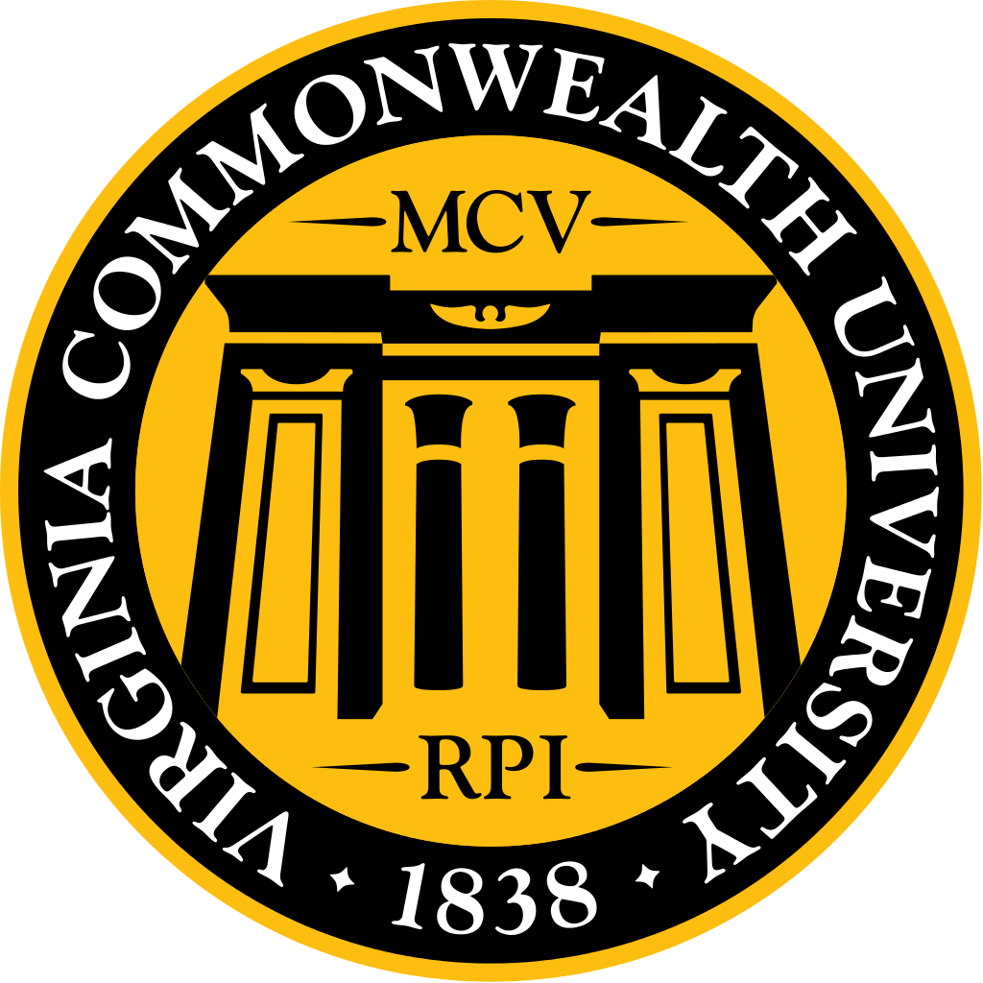
November Dean’s Luncheon Minutes
Highlights
- Our relationship with INOVA will sunset in 2021. The class size will likely drop down to 180 from 216 to insure a good medical education experience. There will be no dilution.
- Dr. Donnenberg is the new Senior Associate Dean for Research. He is very interested in cultivating medical student research and has a good record of NIH funding and publications.
- M1’s schedule is rolled over. It is up to date for M&M and exam dates are set, but beyond that the rest is subject to change.
- Creating a cumulative OSCE for the end of M3 year to prepare for Step2 CS, where our pass rate has been below average.
- Average resident applications for a US MD was 50. Average for IMGs was 135.
- AAMC medical school applications are down 4%. VCU received 8,700 applications this year.
- We are conducting Multiple Mini Interviews (MMI), which is going well, but we need more interviewers. If you know anyone who has extra time please let us know!
- If you have an extra room or couch, please consider hosting students, it’s a great experience!
- Do your FAFSA! This is the first year it is available before January.
- Thompkins McCall Library is going to start renovation. The first floor will under go a major renovation, with the goal of being done by January 16th or 17th. Then will slowly do the other floors, one by one.
- Board Scores:
  - Results are only sent out to the class. The Class of 2018 average was 230, similar to the class of 2017. The class of 2018 had more failures, but was still above national average for first time pass rate. Many scores were extraordinary.
  - Class of 2017 Step 2 CK average ~244. Several 270+ and many 260+. 60 something scored 250+. Only two failures. Results still coming in.
  - Step 2 CS scores have been slow to come back. Only one failure so far, Atlanta.

Dean Strauss
- INOVA
  - Notification was sent out that our relationship will sunset in 2021. This was anticipated and actually stunned that this didn’t happen earlier. They extended the 5year contract last year. Craig Cheifetz, regional dean of VCU School of Medicine INOVA campus, had no part in it. It was the INOVA health system that was driving this.
  - Important thing is that there will be no impact on anyone going to INOVA until the contract ends. We wont send students after this applicant year.
  - This means a number of things. One is that we will not make any of our students go to rotations that are substandard or detrimental to their education. This may mean that we may have to drop down our class number. Likely will go down to 180 students, down from 216. This is to insure a good medical education experience. There will be no dilution. If it turns out that we have the capacity to educate more at high standards then we can titrate up. Dr. Whitehurst-Cook has to enter info to the AAMC to ensure we are providing good educational experience.
  - INOVA will have a relationship with UVA. Interesting this was announced before the contract was signed. We suspect that INOVA will soon have a freestanding 4 year medical college. We were unwilling to pay for it because we were concerned they weren’t committed fully to VCU, which now seems that this is true.
  - Craig Cheifetz (Dean of INOVA campus) and the Medical Education staff is committed to VCU and they are upset that their seniors took a successful relationship and put it in the trash can. They didn’t even know that this announcement was coming. Dr. Cheifetz was excluded from the decision process. He was actually here at MCV when he got the word.
  - Q: Is there any concern for VCU’s reputation in terms of recruiting students?
    - INOVA is more of a community hospital experience. I don’t know what the impact will be but given the fact we have over 10,000 applicants and have difficulty picking, we do not anticipate any decline in interest and if there is it will likely be a very negligible effect.
  - Q: How will the decrease in class size effect the school?
    - We will not raise tuition to make up for the decreased class size. This may actually be a very good move. Mr. Price is now head and not fond of medical education. There are concerns that there may be fewer dollars for GME funding. Not very friendly to academic medical centers. Key positions that support funds for medical education are not necessarily our friends, so the class size reduction is probably a good move. But we have LCME approval for 216 so we can always go back up. We will just wait and see what happens.
    - No impact on students applying to residency out of INOVA. It is invisible. There is no concern.
- New Senior Associate Dean for Research, Dr. Donnenberg. He is hoping to come to a Dean’s luncheon. He is very interested in medical student research and in cultivating student research. He is an infectious disease specialist and has a very nice record of NIH funding and publications.
- For the State, not so happy future. We expect if there is not a reversal in the funds, the University will experience a budget cut this year. Impact on the SOM is minimal. But if the budget cuts continue into the future that is bad. Working on mitigation strategy. I will never support increase in tuition. No more than the CPI, which was .7% last year. With student debt increasing, we are very aware of protecting your pocket books.
- Major champagne. We will start paying out the scholarships and have actually already started.
- Jim and Fran McGlothlin are going to receive honorary degrees. Final beautification should be done by December 5th, not sure if that will happen.
- Dr. Buckley was named the new Dean of VCU School of Medicine. MSG sent him a very nice welcoming email.

Dr. Diane Biskobing, Assistant Dean for Medical Education
- M1/M2s – just studying.
- M1’s schedule is rolled over. It is up to date for M&M, but beyond that don’t believe what you see. Exam dates are set, but other wise don’t believe what you see, it could change.

Dr. Chris Woleben
- Military match at end of this month. – should be confident.
- Urology & optho match first few weeks of January – most had more than 12 interviews and one had over 30 interviews.
- Ortho – we have a lot of students going into ortho, which has been giving me gray hair, but some have parallel plans in place. All should match.
- Dean Strauss: if you are ortho, please go see Steve Kates in January, he is happy to make phone calls for students.
- Ortho video interviews. ENT did something similar. Working with them to prepare them.
- ED standardized video. With holistic review hard to get interpersonal skills so there is a study being done on standardized video. The videos will be computer scored. If this goes forward, students will get a score based on the computer. There is concern about expense, which will likely fall on the applicant. I am one of two working on this from student affairs, hoping that this does not pass.
- I have talked with all the ED applicants about how to do skype interviews.
- Concern about money going to interviews and the number of applications. Average number of resident applications for a US MDs was 50. Average applications for IMGs was 135. Looking into possibility of a tiered application.
- I am Chair of ERAS advisory committee. Meeting with all the people behind ERAS.
- Match rates are MD 95%s and DO 75%. Could dilute.
- Gold Humanism award ceremony will likely be the week of MATCH. Working on setting up that banquet.

Dr. Mark Ryan, Assistant Dean for Clinical Medical Education
- Talking to the M2s in about 20 minutes about clerkships.
- Several ongoing projects:
- End of M3 year, a cumulative osce to prepare for Step2 CS, where our pass rate has been below average
- There has been a lot of discussion about the t score for clerkship grading. Looking at that and the grade distributions.
- EPA project. It is now a large movement across medical schools.
- Looking into specific things to prepare for intern year.
- IM is making a lot of changes, such as point of observation feedback, as opposed to submitting feedback 2 weeks after working with you. Should be a lot more helpful form of feedback.
- The rest is typical scheduling.

Admissions, Dr. Whitehurst-Cook
- AAMC medical school applications are down 4%. 8700 applications this year, so we are a little low and it has been low but we expect more to continue to come in.
- M4 elective going well, but M4s are busy. We are looking to take more M3s in elective, maybe up to 8. It has been very successful, especially for those interested in academics. Get to go to the academic development committee, infused with papers from the AAMC, and get to see all the behind the scenes.
- M1s are taking over tour guides.
- If you have an extra room or couch please host students, consider, it is a great expereicne.
- Trying to do 700 interviews. Down from 900 last year. We are doing the MMI, which is going well, but we need more interviewers. We are doing the same model as Stanford, who is 2 years ahead of us, and apparently they had the same problem of needing more interviewers. We have alumni, practicing practitioners, community members, psych, teachers, principals, all walks of life. We then train them and get them prepared. If you know anyone who has extra time please let us know!

Financial Aid, Pemra Cetin
- Do your FAFSA! This is the first year it is available before January. Right before break you will get an email to do your fafsa.
- January through May I will be conducting 1-1 meetings for fourth year students. Will be required for any students with $250,000+. I will tell you how to look up your loan history.
- The scholarship we know and have done before, need access, is gone, but there is a new one. The new one is the same concept, you still have to pay for it, but nothing else exists.
- Parent’s income is mandatory across the board. This allows us, and no one else, look at your parents. This is because we do not have unlimited money. Based on FAFSA we are 0 need. We have some merit based, but most are need.
- Paula is a new employee in the financial aid office. Comes from the other office. She is very knowledgeable and very pleasant. She is undergoing new job training and learning about medical school. You will like her, come say hi! Bonne retired after almost 40 years.

Lelia Brinegar, Assistant Dean for Curriculum
- Reminder: Echo does not upload immediately.
- Thompkins McCall is going to start renovation. They are starting with the first floor, which will under go a major renovation. The goal is to be done the first floor by January 16 or 17th, just 6 weeks while the university is closed. Then will slowly do the other floors.

MSG
- Reminder of our main forms of communication:
  - MSG website – http://www.vcumsg.org/
  - MSG weekly scoop (attached)
- Please join us for our upcoming events:
  - Medicine Ball 12/2 8-Midnight @ The Richmond Omni
- Update
  - The MSG contacted Dr. Buckley to officially welcome him to the VCU SOM family on behalf of the student body. Dr. Buckley will be meeting with the MSG on January 17th
- Concerns:
  - When is the Gold Humanism Honor Society Induction Ceremony?
    - Will likely be the week of match. Working on setting up that banquet.
  - Dr. Rao suggested that the MSG follow-up regarding the 1838 Scholarship Campaign. We contacted Mr. Thomas Holland but have not heard back. Is it possible to receive an update regarding the campaign efforts?
    - Have started paying out the scholarships.
  - VP of Curriculum: I want to bring up the subject of an incentive for the follow up LCME survey completion. With the original survey last year, the class with the highest percentage completion received $1000. As we have discovered, it is not easy to get students to participate in course surveys without consequences or incentives, which is why I think if we want to achieve 80% completion, we should offer an incentive for this survey as well. We talked with Dr. Digiovanni, who informed us that there was no money in the budget for this purpose. We wanted to bring this up at the Dean's Luncheon to explore other ideas to incentivize survey completion.
    - We do not have excess money for that kind of thing.
    - Per Dr. D: I strongly believe completing surveys is part of your professional obligations and you should not need an incentive to complete them.
    - MSG is looking at their budget to see if we can provide incentive.

Class of 2017 Concerns
- Did VCU release the most recent Step 1 score for Class of 2018? Interested in any changes since the implementation of the new curriculum.
  - Results are only sent out to the class. Class of 2017 results were sent out by Dr. Wood. Class average 230, similar to the class of 2017. The class of 2018 had more failures, but was still above national average for first time pass rate. There were many extraordinary results.
  - Step 2 CK average 244+. Several 270+ and 260+. 60 something scored 250+. Only two failures.
  - Still waiting on Step 2 CS, has been slow. One failure so far, Atlanta.
- When is the Gold Humanism Honor Society Ceremony?
  - Likely match week. Dr. Woleben is working on planning.
- Did we receive our vest/green scrub money back?
  - It was credited.
- What other financial assistance or resources are given for M4s? Even though we graduate in May, we don't have an income until late summer and have increased costs with flights and moving fees.
  - Addressed at last luncheon.
- Is there monthly parking available?
  - Per Dr. Woleben: There is a monthly parking. Call this campus parking center and ask for Mia Williams. There is a monthly parking. Some lots you can’t access before 7. There will be a slightly higher fee for 24h access. Trying to divide up and predict what people need. It is just a numbers game. Dr. Woleben is meeting with parking today and will talk to them about this. They are trying to do one pass with an average price. For now you can get a ticket in the morning and then when you leave you can show them your pass to get out.
Class of 2018 Concerns
- None submitted

Class of 2019 Concerns
- No concerns.
- Update: On mind brain and behavior. Most have liked how it has been de-condensed. Starting a fundraiser for our vests. Just excited to be finishing.

Class of 2020
- No concerns submitted.
- People are wondering if there is any way to schedule the tests differently?
  - A lot of the test scheduling is dictated by the time available. We may or may not be able to make changes, but we will listen to your feedback.
- No questions about cumulative exam. Dr. D’s email was very helpful.

